Eksamen 2013
$$\max{3x_{1}+2x_{2}+5x_{3}}$$
$$s.t \left(\begin{matrix}1 & 2 & 1 \\ 3 & 0 & 1 \\ 1 & 4 & 0\end{matrix}\right)x≤\left(\begin{aligned}430 \\ 460 \\ 420\end{aligned}\right),x≥0$$
Standard form
$$\max{3x_{1}+2x_{2}+5x_{3}}$$
$$s.t\left( \begin{matrix}1 & 2 & 1 & 1 & 0 & 0 \\ 3 & 0 & 1 & 0 & 1 & 0 \\ 1 & 4 & 0 & 0 & 0 & 1\end{matrix}\right)x=\left(\begin{aligned}430 \\ 460 \\ 420\end{aligned}\right),x≥0$$

- Opskriv D
D
$$\min{430y_{1}+460y_{2}+420y_{3}}$$
$$s.t\left(\begin{matrix}1 & 3 & 1 \\ 2 & 2 & 4 \\ 1 & 0 & 0\end{matrix}\right)y≥\left(\begin{aligned}3 \\ 2 \\ 5\end{aligned}\right),y≥0$$
$$⇔\left(\begin{matrix}1 & 3 & 1 \\ 2 & 0 & 4 \\ 1 & 1 & 0 \\ 1 & 0 & 0 \\ 0 & 1 & 0 \\ 0 & 0 & 1\end{matrix}\right)y≥\left(\begin{aligned}3 \\ 2 \\ 5 \\ 0 \\ 0 \\ 0\end{aligned}\right)$$
- Opskriv tableauet tilhørende B og vis det er en brugbar basis
$$A_{B}=\left(\begin{matrix}2 & 1 & 0 \\ 0 & 1 & 1 \\ 4 & 0 & 0\end{matrix}\right)$$
$$\overline{x}={\left(\begin{matrix}2 & 1 & 0 \\ 0 & 2 & 1 \\ 4 & 0 & 0\end{matrix}\right)}^{-1}·\left(\begin{aligned}430 \\ 460 \\ 420\end{aligned}\right)=\left(\begin{matrix}105 \\ 220 \\ 20\end{matrix}\right)$$
Da er basis primalt brugbar
$$c=\left(\begin{matrix}3 & 2 & 5 & 0 & 0 & 0\end{matrix}\right)$$
$$c_{B}=\left(\begin{matrix}2 & 5 & 0\end{matrix}\right)$$
$$\overline{A}={\left(\begin{matrix}2 & 1 & 0 \\ 0 & 2 & 1 \\ 4 & 0 & 0\end{matrix}\right)}^{-1}\left( \begin{matrix}1 & 2 & 1 & 1 & 0 & 0 \\ 3 & 0 & 2 & 0 & 1 & 0 \\ 1 & 4 & 0 & 0 & 0 & 1\end{matrix}\right)=\left(\begin{matrix}\frac{1}{4} & 1 & 0 & 0 & 0 & \frac{1}{4} \\ \frac{1}{2} & 0 & 1 & 1 & 0 & -\left(\frac{1}{2}\right) \\ 2 & 0 & 0 & -2 & 1 & 1\end{matrix}\right)$$
$$\overline{c}=\left(\begin{matrix}3 & 2 & 5 & 0 & 0 & 0\end{matrix}\right)-\left(\begin{matrix}2 & 5 & 0\end{matrix}\right)\left(\begin{matrix}\frac{1}{4} & 1 & 0 & 0 & 0 & \frac{1}{4} \\ \frac{1}{2} & 0 & 1 & 1 & 0 & -\left(\frac{1}{2}\right) \\ \frac{5}{2} & 0 & 0 & 0 & 1 & -\left(\frac{1}{2}\right)\end{matrix}\right)=\left(\begin{matrix}0 & 0 & 0 & -5 & 0 & 2\end{matrix}\right)$$

$$c_{B}\overline{x}=\left(\begin{matrix}2 & 5 & 0\end{matrix}\right)\left(\begin{matrix}105 \\ 220 \\ 250\end{matrix}\right)=1310$$
Nu på tableau
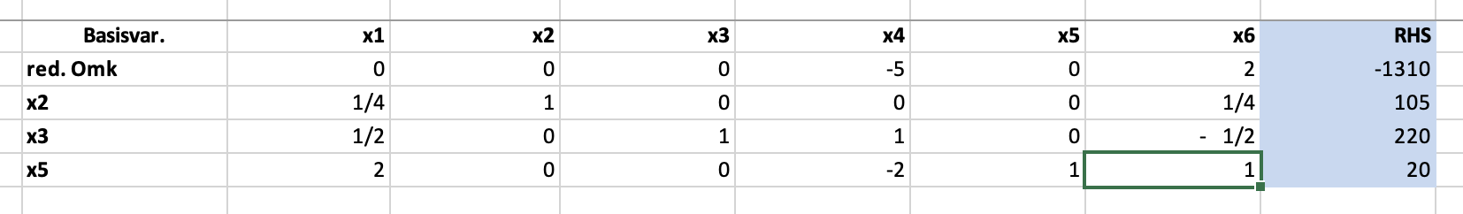
- Løs med simplex
X6 går ind x5 går ud
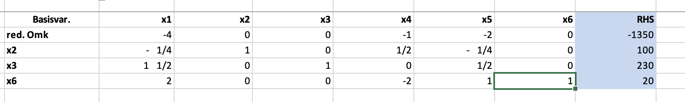
Da er vi optimale da ingen positive reducerede omkostninger da dualt brugbar og ingen negative basisvariable da primalt brugbar da både primalt og dualt brugbar er løsningen optimal
Med
$$x^{⋆}=\left(\begin{aligned}0 \\ 100 \\ 230 \\ 0 \\ 0 \\ 20\end{aligned}\right)$$
Og dual løsning
$$\left(\begin{matrix}2 & 5 & 0\end{matrix}\right){\left(\begin{matrix}2 & 1 & 0 \\ 0 & 2 & 0 \\ 4 & 0 & 1\end{matrix}\right)}^{-1}=\left(\begin{matrix}1 & 2 & 0\end{matrix}\right)$$
Med
$$c^{T}x=\left(\begin{matrix}3 & 2 & 5 & 0 & 0 & 0\end{matrix}\right)\left(\begin{aligned}0 \\ 100 \\ 230 \\ 0 \\ 0 \\ 20\end{aligned}\right)=1350$$
$$y^{T}b^{}=\left(\begin{matrix}1 & 2 & 0\end{matrix}\right)\left(\begin{aligned}430 \\ 460 \\ 420\end{aligned}\right)=1350$$
Fælles objektværdi per stærk dualitet

- Højreside vektor ænderes med et alpha
Hvornår er basisen stadig optimal for P?
Basis optimal hvis og kun hvis dualt og primalt brugbar en ændring i HS vektor ændre ikke på dual brugbarhed da tjekker vi blot hvornår den er primalt brugbar
$${\left(\begin{matrix}2 & 1 & 0 \\ 0 & 2 & 0 \\ 4 & 0 & 1\end{matrix}\right)}^{-1}\left(\begin{aligned}430+a \\ 460 \\ 420\end{aligned}\right)=\left(\begin{matrix}\frac{a+430}{2}-115 \\ 230 \\ 880-2·\left(a+430\right)\end{matrix}\right)$$
$$\frac{a+430}{2}-115≥0$$
$⇕$ Uligheden løses for a vha. WordMat.
$$a≥-200$$

$$880-2·\left(a+430\right)≥0$$
$⇕$ Uligheden løses for a vha. WordMat.
$$a≤10$$
Da basis stadig optmal $⇔a∈\left[-200,10\right]$

- Objektværdien ændres hvornår er den samme basis stadig optimal
Igen en ændring i obj ændre ikke på primal brugbarhed kun dual så hvis dual brugbar da optimal

$$\overline{c}=\left(\begin{matrix}\left(1+β\right)3 & 2 & 5 & 0 & 0 & 0\end{matrix}\right)-\left(\begin{matrix}2 & 5 & 0\end{matrix}\right){\left(\begin{matrix}2 & 1 & 0 \\ 0 & 2 & 0 \\ 4 & 0 & 1\end{matrix}\right)}^{-1}\left( \begin{matrix}1 & 2 & 1 & 1 & 0 & 0 \\ 3 & 0 & 2 & 0 & 1 & 0 \\ 1 & 4 & 0 & 0 & 0 & 1\end{matrix}\right)=\left(\begin{matrix}3·\left(β+1\right)-7 & 0 & 0 & -1 & -2 & 0\end{matrix}\right)≤0$$
$$3\left(β+1\right)-7≥0$$
$⇕$ Uligheden løses for beta vha. WordMat.
$$β≥\frac{4}{3}$$
- Ved ændring i B smide vi blot ny $\overline{x}$ in i tableau og reoptimerer
$$\overline{x}={\left(\begin{matrix}2 & 1 & 0 \\ 0 & 2 & 0 \\ 4 & 0 & 1\end{matrix}\right)}^{-1}\left(\begin{aligned}450 \\ 460 \\ 400\end{aligned}\right)=\left(\begin{matrix}110 \\ 230 \\ -40\end{matrix}\right)$$
$$\left(\begin{matrix}3 & 2 & 5 & 0 & 0 & 0\end{matrix}\right)\left(\begin{aligned}0 \\ 110 \\ 230 \\ 0 \\ 0 \\ -40\end{aligned}\right)=1370$$
Vi husker at justrer objektværdi også,
På tableau:
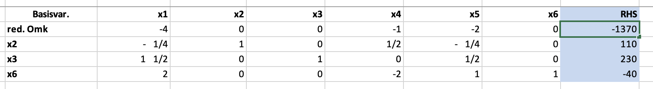
Nu reoptimerer vi med dual simplex
X6 skal ud da den er negativ
Da x4 er den eneste negative går den ind
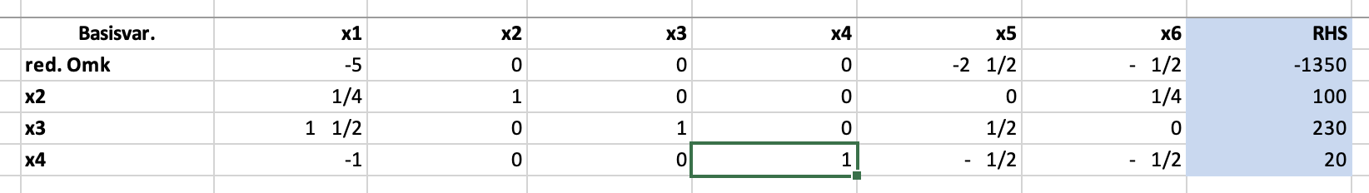
Ne ser vi at vi er optimale da reducerede omkostninger ikke positive og basisvariable positive
Da er ny løsning
$$x^{⋆}=\left(\begin{aligned}0 \\ 100 \\ 230 \\ 20 \\ 0 \\ 0\end{aligned}\right)$$
Med $c^{T}x^{⋆}=\left(\begin{matrix}3 & 2 & 5 & 0 & 0 & 0\end{matrix}\right)\left(\begin{aligned}0 \\ 100 \\ 230 \\ 20 \\ 0 \\ 0\end{aligned}\right) =1350$

Opg 2
- Find min cost udspændende træ
For at finde træet bruger vi kruskals algoritme hvor vi itterativt tilføjer den billigste sti som ikke skaber en kreds

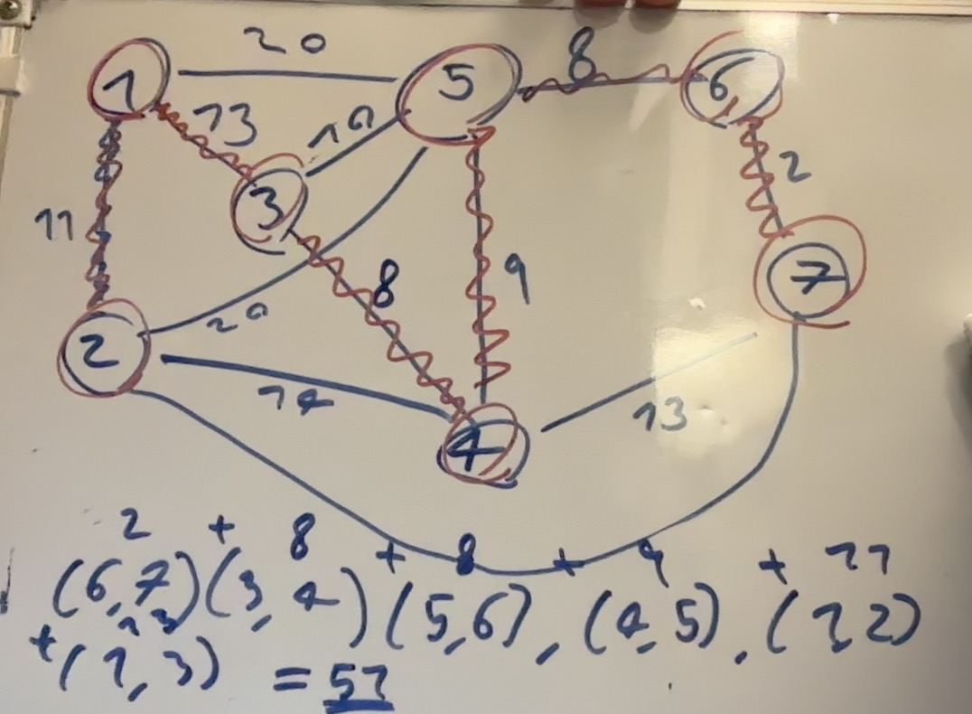
- Opskriv transportproblem som LP problem
$$\min{c^{T}·f}$$
$$\left(\begin{matrix}1 & 1 & 1 & 1 & 0 & 0 & 0 & 0 & 0 & 0 & 0 & 0 \\ 0 & 0 & 0 & 0 & 1 & 1 & 1 & 1 & 0 & 0 & 0 & 0 \\ 0 & 0 & 0 & 0 & 0 & 0 & 0 & 0 & 1 & 1 & 1 & 1 \\ 1 & 0 & 0 & 0 & 1 & 0 & 0 & 0 & 1 & 0 & 0 & 0 \\ 0 & 1 & 0 & 0 & 0 & 1 & 0 & 0 & 0 & 1 & 0 & 0 \\ 0 & 0 & 1 & 0 & 0 & 0 & 1 & 0 & 0 & 0 & 1 & 0 \\ 0 & 0 & 0 & 1 & 0 & 0 & 0 & 1 & 0 & 0 & 0 & 1\end{matrix}\right)\left(\begin{aligned}f_{1,1} \\ f_{1,2} \\ f_{1,3} \\ f_{1,4} \\ f_{2,1} \\ … \\ f_{3,4}\end{aligned}\right)=\left(\begin{aligned}15 \\ 25 \\ 10 \\ 5 \\ 15 \\ 15 \\ 15\end{aligned}\right),f≥0$$

$$c=\left(\begin{aligned}10 \\ 2 \\ 20 \\ 11 \\ 12 \\ 7 \\ 9 \\ 20 \\ 4 \\ 14 \\ 16 \\ 18\end{aligned}\right)$$
- Find brugbar basis ved nordvest metoden
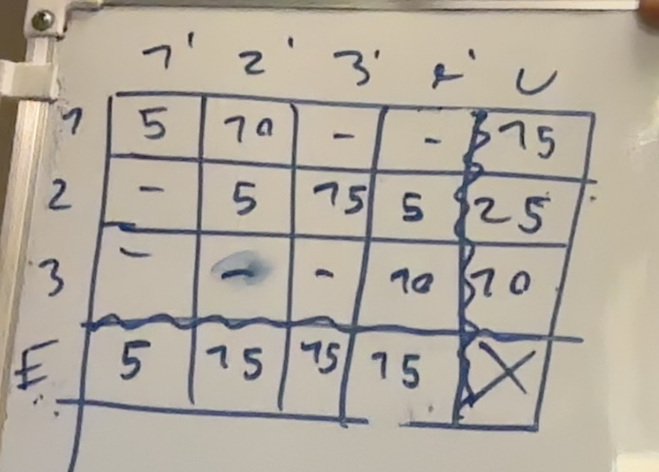
- Løs transportproblemet
Vi starter med at finde en måske bedre startbasis ved en grådig algoritme der finder en brugbar løsning
Vi starter fra udbyder 1 hvor vi tager det der er aller billigst for ham efter tager vi det billigste tilgængelig for udbyder 2 og til sidst må udbyder 3 tage resten
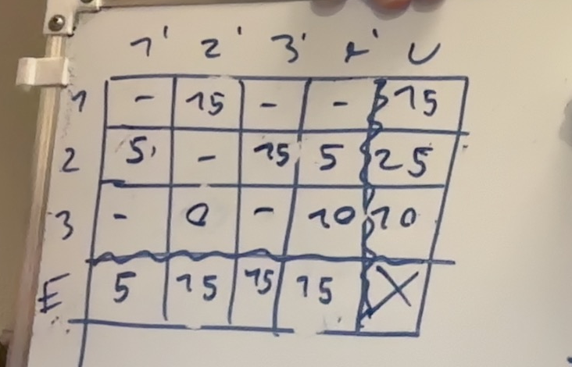
Denne metode giver os denne løsning
Vi finder de duale variable til denne løsning
$$u_{1}+e_{2}=2$$
$$u_{2}+e_{1}=12$$
$$u_{2}+e_{3}=9$$
$$u_{2}+e_{4}=20$$
$$u_{3}+e_{2}=4$$
$$u_{3}+e_{4}=18$$
$$e_{4}=0$$
$⇕$ Ligningssystemet løses for u_1,e_2,u_2,e_1,e_3,e_4,u_3 vha. WordMat's 'Løs Ligninger' funktion,
$$u_{1}=16 ∧ e_{2}=-14 ∧ u_{2}=20 ∧ e_{1}=-8 ∧ e_{3}=-11 ∧ e_{4}=0 ∧ u_{3}=18$$

$$\overline{c}=\left(\begin{aligned}10 \\ 2 \\ 20 \\ 11 \\ 12 \\ 7 \\ 9 \\ 20 \\ 4 \\ 14 \\ 16 \\ 18\end{aligned}\right)-\left(\begin{matrix}1 & 0 & 0 & 1 & 0 & 0 & 0 \\ 1 & 0 & 0 & 0 & 1 & 0 & 0 \\ 1 & 0 & 0 & 0 & 0 & 1 & 0 \\ 1 & 0 & 0 & 0 & 0 & 0 & 1 \\ 0 & 1 & 0 & 1 & 0 & 0 & 0 \\ 0 & 1 & 0 & 0 & 1 & 0 & 0 \\ 0 & 1 & 0 & 0 & 0 & 1 & 0 \\ 0 & 1 & 0 & 0 & 0 & 0 & 1 \\ 0 & 0 & 1 & 1 & 0 & 0 & 0 \\ 0 & 0 & 1 & 0 & 1 & 0 & 0 \\ 0 & 0 & 1 & 0 & 0 & 1 & 0 \\ 0 & 0 & 1 & 0 & 0 & 0 & 1\end{matrix}\right)\left(\begin{aligned}16 \\ 20 \\ 18 \\ -8 \\ -14 \\ -11 \\ 0\end{aligned}\right)=\left(\begin{matrix}2 \\ 0 \\ 15 \\ -5 \\ 0 \\ 1 \\ 0 \\ 0 \\ -6 \\ 10 \\ 9 \\ 0\end{matrix}\right)$$
Da skal f_3,1 ind
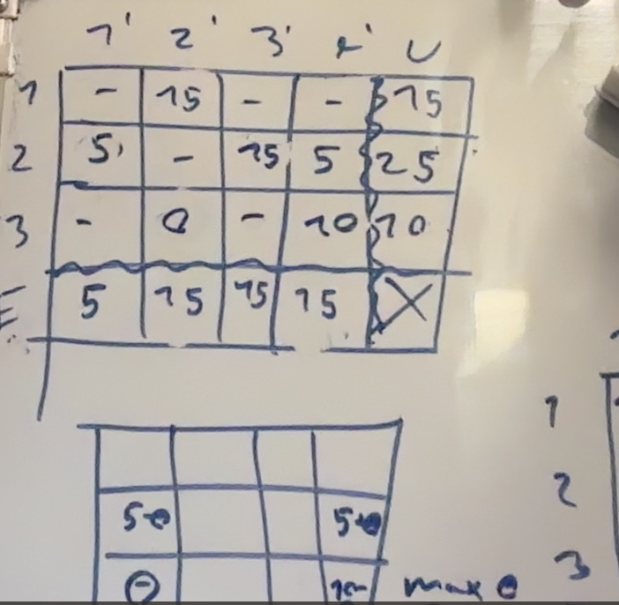
Vi opdaterer tabel
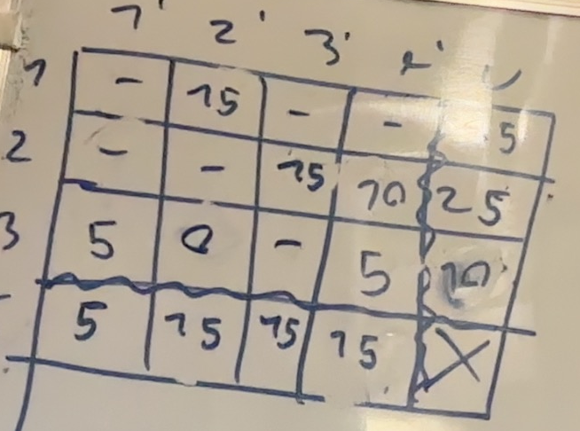
Nu regner vi reducerede omkostninger igen

$$u_{1}+e_{2}=2$$
$$u_{3}+e_{1}=4$$
$$u_{2}+e_{3}=9$$
$$u_{2}+e_{4}=20$$
$$u_{3}+e_{2}=4$$
$$u_{3}+e_{4}=18$$
$$e_{4}=0$$
$⇕$ Ligningssystemet løses for u_1,e_2,u_3,e_1,u_2,e_3,e_4 vha. WordMat's 'Løs Ligninger' funktion,
$$u_{1}=16 ∧ e_{2}=-14 ∧ u_{3}=18 ∧ e_{1}=-14 ∧ u_{2}=20 ∧ e_{3}=-11 ∧ e_{4}=0$$
$$\overline{c}=\left(\begin{aligned}10 \\ 2 \\ 20 \\ 11 \\ 12 \\ 7 \\ 9 \\ 20 \\ 4 \\ 14 \\ 16 \\ 18\end{aligned}\right)-\left(\begin{matrix}1 & 0 & 0 & 1 & 0 & 0 & 0 \\ 1 & 0 & 0 & 0 & 1 & 0 & 0 \\ 1 & 0 & 0 & 0 & 0 & 1 & 0 \\ 1 & 0 & 0 & 0 & 0 & 0 & 1 \\ 0 & 1 & 0 & 1 & 0 & 0 & 0 \\ 0 & 1 & 0 & 0 & 1 & 0 & 0 \\ 0 & 1 & 0 & 0 & 0 & 1 & 0 \\ 0 & 1 & 0 & 0 & 0 & 0 & 1 \\ 0 & 0 & 1 & 1 & 0 & 0 & 0 \\ 0 & 0 & 1 & 0 & 1 & 0 & 0 \\ 0 & 0 & 1 & 0 & 0 & 1 & 0 \\ 0 & 0 & 1 & 0 & 0 & 0 & 1\end{matrix}\right)\left(\begin{aligned}16 \\ 20 \\ 18 \\ -14 \\ -14 \\ -11 \\ 0\end{aligned}\right)=\left(\begin{matrix}8 \\ 0 \\ 15 \\ -5 \\ 6 \\ 1 \\ 0 \\ 0 \\ 0 \\ 10 \\ 9 \\ 0\end{matrix}\right)$$
Da går 1,4 ind
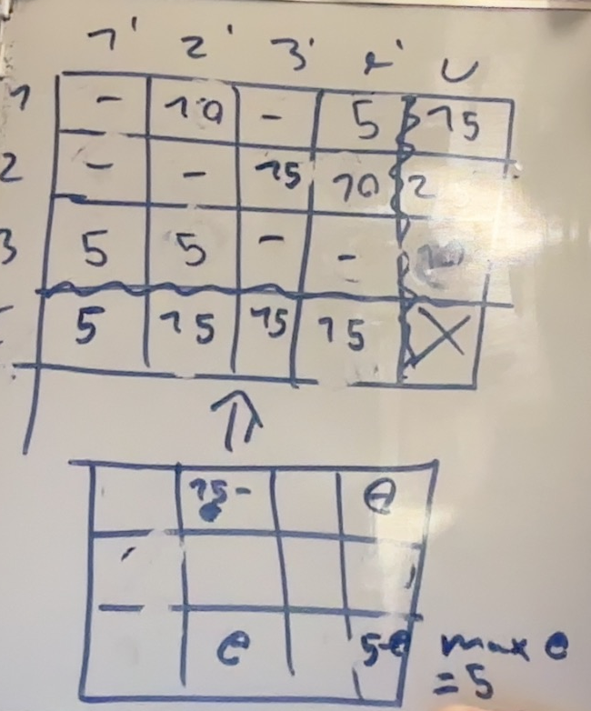
$$u_{1}+e_{2}=2$$
$$u_{3}+e_{1}=4$$
$$u_{2}+e_{3}=9$$
$$u_{2}+e_{4}=20$$
$$u_{3}+e_{2}=4$$
$$u_{1}+e_{4}=11$$
$$e_{4}=0$$
$⇕$ Ligningssystemet løses for u_1,e_2,u_3,e_1,u_2,e_3,e_4 vha. WordMat's 'Løs Ligninger' funktion,
$$u_{1}=11 ∧ e_{2}=-9 ∧ u_{3}=13 ∧ e_{1}=-9 ∧ u_{2}=20 ∧ e_{3}=-11 ∧ e_{4}=0$$

$$\overline{c}=\left(\begin{aligned}10 \\ 2 \\ 20 \\ 11 \\ 12 \\ 7 \\ 9 \\ 20 \\ 4 \\ 14 \\ 16 \\ 18\end{aligned}\right)-\left(\begin{matrix}1 & 0 & 0 & 1 & 0 & 0 & 0 \\ 1 & 0 & 0 & 0 & 1 & 0 & 0 \\ 1 & 0 & 0 & 0 & 0 & 1 & 0 \\ 1 & 0 & 0 & 0 & 0 & 0 & 1 \\ 0 & 1 & 0 & 1 & 0 & 0 & 0 \\ 0 & 1 & 0 & 0 & 1 & 0 & 0 \\ 0 & 1 & 0 & 0 & 0 & 1 & 0 \\ 0 & 1 & 0 & 0 & 0 & 0 & 1 \\ 0 & 0 & 1 & 1 & 0 & 0 & 0 \\ 0 & 0 & 1 & 0 & 1 & 0 & 0 \\ 0 & 0 & 1 & 0 & 0 & 1 & 0 \\ 0 & 0 & 1 & 0 & 0 & 0 & 1\end{matrix}\right)\left(\begin{aligned}11 \\ 20 \\ 13 \\ -9 \\ -9 \\ -11 \\ 0\end{aligned}\right)=\left(\begin{matrix}8 \\ 0 \\ 20 \\ 0 \\ 1 \\ -4 \\ 0 \\ 0 \\ 0 \\ 10 \\ 14 \\ 5\end{matrix}\right)$$
Da skal 2,2 ind
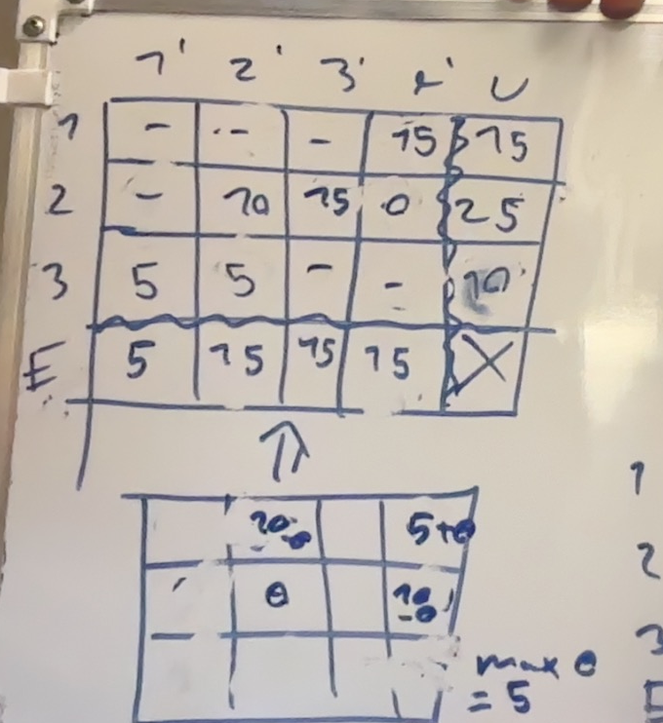
Max theta =10 i denne
$$u_{2}+e_{2}=7$$
$$u_{3}+e_{1}=4$$
$$u_{2}+e_{3}=9$$
$$u_{2}+e_{4}=20$$
$$u_{3}+e_{2}=4$$
$$u_{1}+e_{4}=11$$
$$e_{4}=0$$
$⇕$ Ligningssystemet løses for u_2,e_2,u_3,e_1,e_3,e_4,u_1 vha. WordMat's 'Løs Ligninger' funktion,
$$u_{2}=20 ∧ e_{2}=-13 ∧ u_{3}=17 ∧ e_{1}=-13 ∧ e_{3}=-11 ∧ e_{4}=0 ∧ u_{1}=11$$
$$\left(\begin{aligned}10 \\ 2 \\ 20 \\ 11 \\ 12 \\ 7 \\ 9 \\ 20 \\ 4 \\ 14 \\ 16 \\ 18\end{aligned}\right)-\left(\begin{matrix}1 & 0 & 0 & 1 & 0 & 0 & 0 \\ 1 & 0 & 0 & 0 & 1 & 0 & 0 \\ 1 & 0 & 0 & 0 & 0 & 1 & 0 \\ 1 & 0 & 0 & 0 & 0 & 0 & 1 \\ 0 & 1 & 0 & 1 & 0 & 0 & 0 \\ 0 & 1 & 0 & 0 & 1 & 0 & 0 \\ 0 & 1 & 0 & 0 & 0 & 1 & 0 \\ 0 & 1 & 0 & 0 & 0 & 0 & 1 \\ 0 & 0 & 1 & 1 & 0 & 0 & 0 \\ 0 & 0 & 1 & 0 & 1 & 0 & 0 \\ 0 & 0 & 1 & 0 & 0 & 1 & 0 \\ 0 & 0 & 1 & 0 & 0 & 0 & 1\end{matrix}\right)\left(\begin{aligned}11 \\ 20 \\ 17 \\ -13 \\ -13 \\ -11 \\ 0\end{aligned}\right)=\left(\begin{matrix}12 \\ 4 \\ 20 \\ 0 \\ 5 \\ 0 \\ 0 \\ 0 \\ 0 \\ 10 \\ 10 \\ 1\end{matrix}\right)≥0$$
Da er løsningen optimal

Opg 3
$$\max{3x_{1}+x_{2}+3x_{3}}$$
$$s.t \left(\begin{matrix}-1 & 2 & 1 & 1 & 0 & 0 \\ 0 & 4 & -3 & 0 & 1 & 0 \\ 1 & -3 & 2 & 0 & 0 & 1\end{matrix}\right)x≤\left(\begin{aligned}4 \\ 2 \\ 3\end{aligned}\right),x≥0,x∈Z^{6}$$
- ${\left(\begin{matrix}-1 & 2 & 1 \\ 0 & 4 & -3 \\ 1 & -3 & 2\end{matrix}\right)}^{-1}\left(\begin{aligned}4 \\ 2 \\ 3\end{aligned}\right)=\left(\begin{matrix}\frac{16}{3} \\ 3 \\ \frac{10}{3}\end{matrix}\right)≥0$ da primalt brugbar
$$\overline{c}=\left(\begin{matrix}3 & 1 & 3 & 0 & 0 & 0\end{matrix}\right)-\left(\begin{matrix}3 & 1 & 3\end{matrix}\right){\left(\begin{matrix}-1 & 2 & 1 \\ 0 & 4 & -3 \\ 1 & -3 & 2\end{matrix}\right)}^{-1}\left(\begin{matrix}-1 & 2 & 1 & 1 & 0 & 0 \\ 0 & 4 & -3 & 0 & 1 & 0 \\ 1 & -3 & 2 & 0 & 0 & 1\end{matrix}\right)=\left(\begin{matrix}0 & 0 & 0 & -2 & -3 & -5\end{matrix}\right)≤0$$
Da er basis optimal
Med objektværdi
$$\left(\begin{matrix}3 & 1 & 3\end{matrix}\right)\left(\begin{matrix}\frac{16}{3} \\ 3 \\ \frac{10}{3}\end{matrix}\right)=29$$
$$\overline{A}={\left(\begin{matrix}-1 & 2 & 1 \\ 0 & 4 & -3 \\ 1 & -3 & 2\end{matrix}\right)}^{-1}\left(\begin{matrix}-1 & 2 & 1 & 1 & 0 & 0 \\ 0 & 4 & -3 & 0 & 1 & 0 \\ 1 & -3 & 2 & 0 & 0 & 1\end{matrix}\right)=\left(\begin{matrix}1 & 0 & 0 & \frac{1}{9} & \frac{7}{9} & \frac{10}{9} \\ 0 & 1 & 0 & \frac{1}{3} & \frac{1}{3} & \frac{1}{3} \\ 0 & 0 & 1 & \frac{4}{9} & \frac{1}{9} & \frac{4}{9}\end{matrix}\right)$$
Tableau:
 | $$\left(\begin{matrix}0 & 0 & 0 & -2 & -3 & -5\end{matrix}\right)$$ | -29
$$\left(\begin{aligned}x_{1} \\ x_{2} \\ x_{3}\end{aligned}\right)$$ | $$\left(\begin{matrix}1 & 0 & 0 & \frac{1}{9} & \frac{7}{9} & \frac{10}{9} \\ 0 & 1 & 0 & \frac{1}{3} & \frac{1}{3} & \frac{1}{3} \\ 0 & 0 & 1 & \frac{4}{9} & \frac{1}{9} & \frac{4}{9}\end{matrix}\right)$$ | $$\left(\begin{matrix}\frac{16}{3} \\ 3 \\ \frac{10}{3}\end{matrix}\right)$$

- $\left(\begin{matrix}\frac{16}{3} \\ 3 \\ \frac{10}{3}\end{matrix}\right)$ afrundet
$$x_{af}=\left(\begin{aligned}5 \\ 3 \\ 3\end{aligned}\right)$$
$$\left(\begin{matrix}-1 & 2 & 1 & 1 & 0 & 0 \\ 0 & 4 & -3 & 0 & 1 & 0 \\ 1 & -3 & 2 & 0 & 0 & 1\end{matrix}\right)\left(\begin{aligned}5 \\ 3 \\ 3 \\ 0 \\ 0 \\ 0\end{aligned}\right)=\left(\begin{matrix}4 \\ 3 \\ 2\end{matrix}\right)$$
$$ikke brugbar løsning…$$

- Lav gomory snit for variabel 1,3
1.
$$x_{1}+x_{6}+x_{7}=5$$
3
$$x_{3}+x_{8}=3$$

